How to Update Email Notification Settings in SFDC
Task Notification Emails
- Go to View Profile in upper right-hand corner and click on ‘Settings’
- Expand Email section on left of screen
- Select ‘My Email Settings’
- Under My Email Settings, uncheck the ‘Email me when someone assigns me a task’
- Click Save
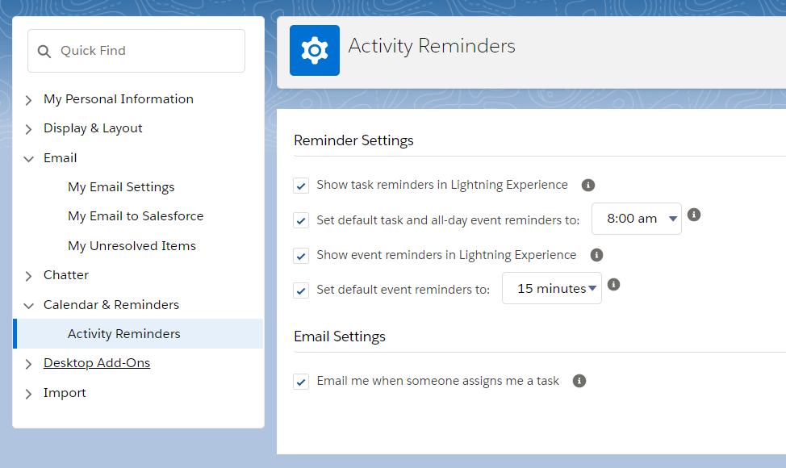

Chatter Notification Emails
- Go to View Profile in upper right-hand corner and click on ‘Settings’
- Expand Chatter section on left of screen
- Select ‘Email Notifications’
- To remove all email notifications
  - Uncheck the ‘Receive Emails’ checkbox and click ‘Save’
- To Remove specific email notifications
  - Uncheck the individual notification checkboxes for the emails you no longer with to receive (and v.v.) and click Save
